**OUTPUT OF THE PROGRAM FOR INTEGER 5**



**TABULATE ABOVE DATA**

|  |  |  |
| --- | --- | --- |
| **SR NO** | **Fibonacci Sequence** | **Remainders when divided by 5** |
| 1 | 0 | 0 |
| 2 | 1 | 0 |
| 3 | 1 | 0 |
| 4 | 2 | 2 |
| 5 | 3 | 3 |
| 6 | 5 | 0 |
| 7 | 8 | 3 |
| 8 | 13 | 3 |
| 9 | 21 | 1 |
| 10 | 34 | 4 |
| 11 | 55 | 0 |
| 12 | 89 | 4 |
| 13 | 144 | 4 |
| 14 | 233 | 3 |
| 15 | 377 | 2 |
| 16 | 610 | 0 |
| 17 | 987 | 2 |
| 18 | 1597 | 2 |
| 19 | 2584 | 4 |
| 20 | 4184 | 1 |
| 21 | 6765 | 0 |
| 22 | 10946 | 1 |
| 23 | 17711 | 1 |
| 24 | 28657 | 2 Ending Here |
| 25 | 46368 | 3 |

**PATTERN OBTAINED**

Step 4 : Now grab a paper and draw a circle on it. Take a random point on it and start writing all the numbers from 0 to 4. Since we are dividing by 5, the range of the remainders will be 0 up to 4 only. step 4 : Now grab a paper and draw a circle on it. Take a random point on it and start writing all the numbers from 0 to 4. Since we are dividing by 5, the range of the remainders will be 0 up to 4 only.

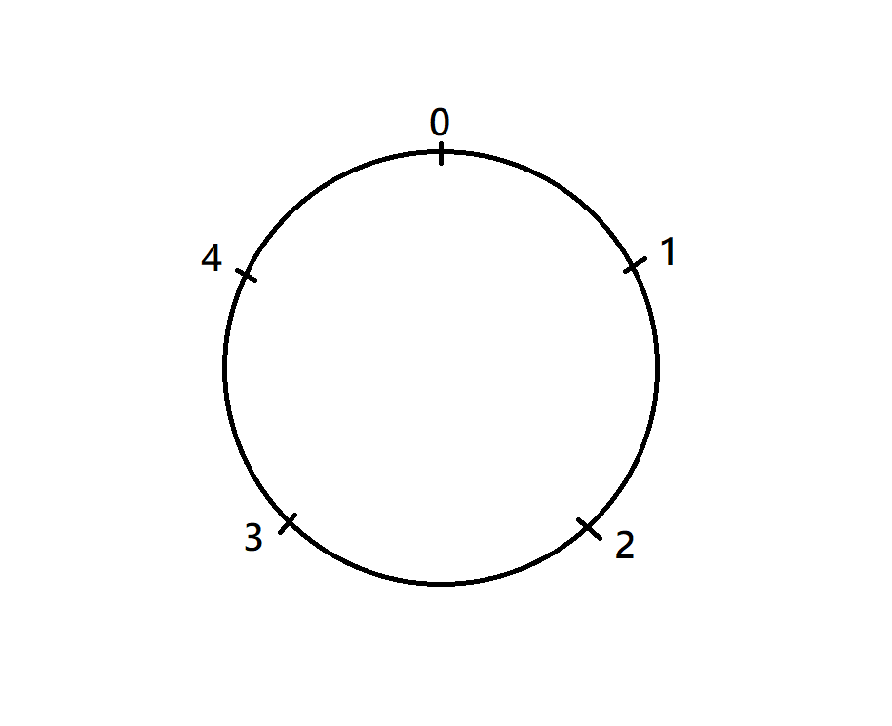

step 5 : Now sequentially join all the remainders from the remainder sequence. Trace a line from each consequtative remainder and after finishing that you will see a star formed by tracing all remainders. Start with 0 then 2 then 3 then 0 then 3 then 3 and so on. Refere the table.

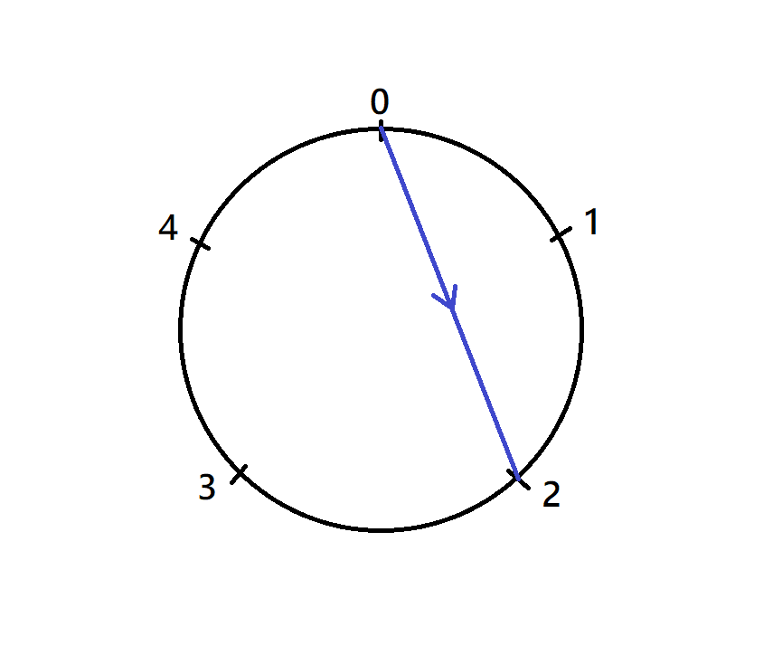

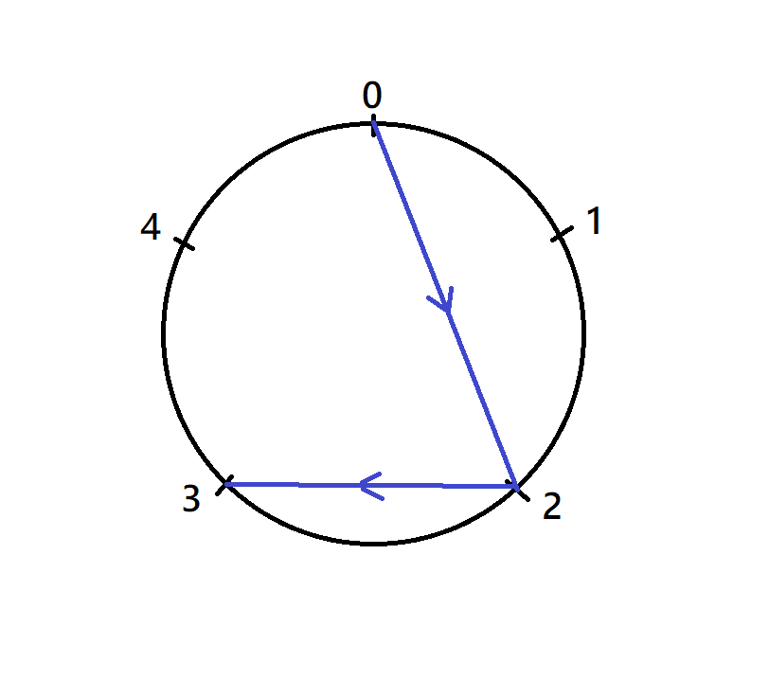

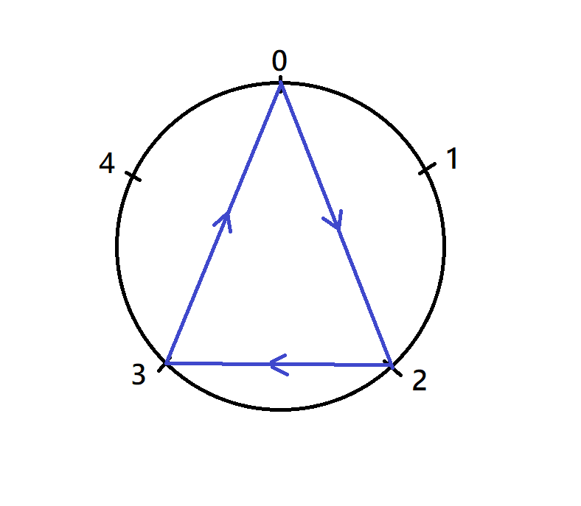

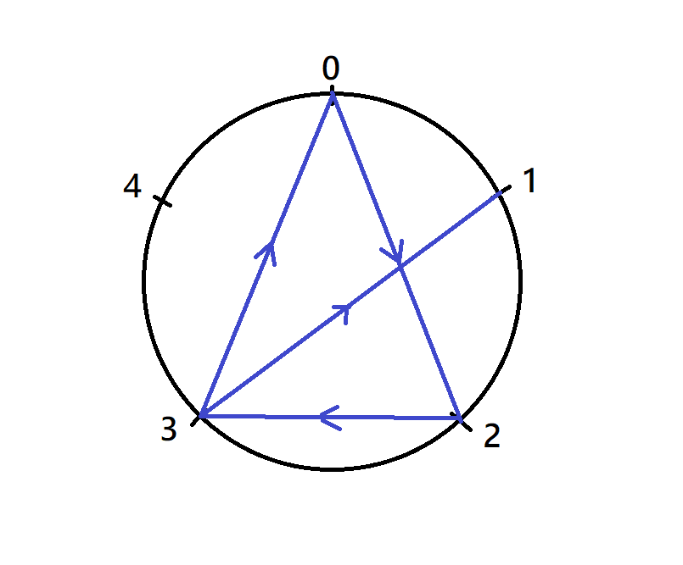

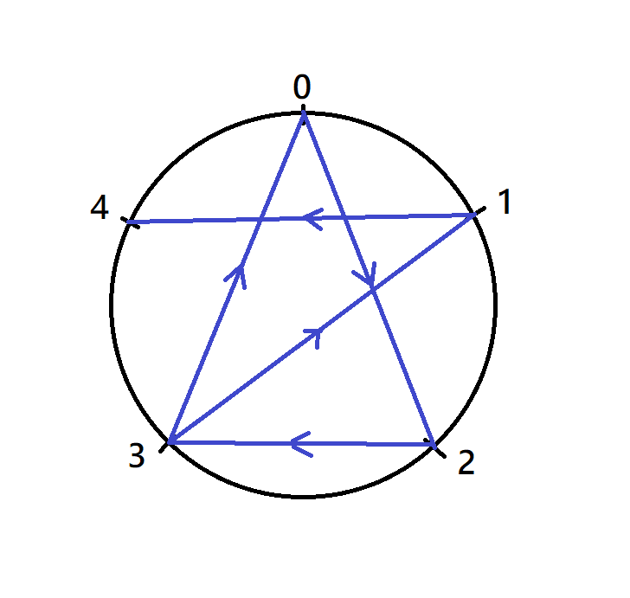

If we continuou these tracings we can observe that the pattern starts repeating itself againg. That will be the end of tracing. The pattern obtaind by ending will be the final pattern. In this case we are getting a beautiful star pattern.

**FINAL OUTPUT PATTERN**

